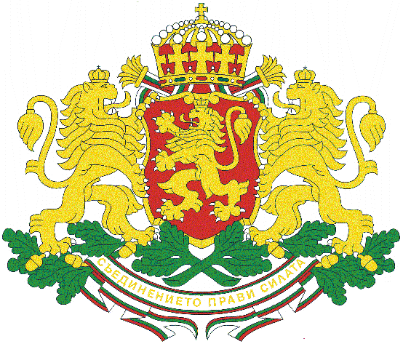
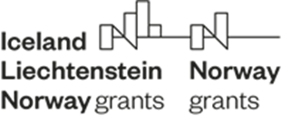

Guidelines for Аpplicants

Travel Support Scheme under the Fund for Bilateral Relations within the EEA FM and NFM 2014 – 2021

- Objective and Scope of the Travel Support Scheme
The Travel Support Scheme has been launched under the Fund for Bilateral Relations (hereinafter referred to as “FBR”) with the purpose of providing opportunities for networking, exchange and transfer of knowledge, experience and best practices and to promote cooperation between Bulgarian entities and entities in the Donor States and/or international organizations. The Travel Support Scheme will offer small scale financial support on an ongoing basis for participation in seminars, workshops, conferences, etc. events with clear bilateral dimension within all programme areas under the EEA FM and NFM 2014 – 2021, based on applications submitted by the eligible beneficiaries.
Participation in international events conducted in the Beneficiary States under the EEA FM and NFM 2014 – 2021 (Bulgaria, Croatia, Check Republic, Estonia, Hungary, Latvia, Lithuania, Malta, Romania, Slovakia, Slovenia and Portugal), Donor States or other EU member states, is subject to support, if representatives from at least one of the Donor States participate in the event.
Central Coordination Unit Directorate within the Administration of the Council of Ministers acts as the National Focal Point (hereinafter referred to as “NFP”) for the EEA FM and NFM 2014 – 2021. Based on the Regulations on the implementation of the EEA FM and NFM 2014 – 2021 and the Agreement on the Fund for Bilateral Relations, the NFP has been entrusted with the implementation of the FBR and the Travel Support Scheme in particular.
- Budget under the Travel Support Scheme
The total eligible budget under the Travel Support Scheme is 100 000 EUR. This amount is available throughout the duration of the FBR till 30 April 2025. The Scheme’s implementation, including utilization of funds will be monitored by the Joint Committee for Bilateral Funds (JCBF), which is composed of representatives from the National Focal Point, the Bulgarian Ministry of Foreign Affairs, the Ministries of Foreign Affairs of Kingdom of Norway, Iceland and Liechtenstein. FMO representatives participate in the JCBF meetings as observers.

- Eligible applicants
The eligible applicants under the Travel Support Scheme are as follows:
- National Focal Point, Certifying Authority and Audit Authority for EEA FM and NFM 2014 – 2021;
- Ministries and other state institutions in charge of implementing national policies in the programme areas under the EEA FM and NFM 2014 – 2021 listed below;
- Universities and Scientific organizations;
- Local and regional authorities;
- Public Donor state entities, international organizations, working in the field of programme areas under the EEA FM and NFM 2014 – 2021.

- Grant rate and eligible expenditures under the Travel Support Scheme
The Travel Support Scheme will provide 100% grant. The maximum amount eligible per entity for participation in seminars, workshops, conferences, etc. events with bilateral dimension within all programme areas under the EEA FM and NFM 2014 – 2021 is EUR 5000. The grant will be provided as reimbursement of incurred and verified actual costs, supported by relevant supporting documents.
Eligible expenditures include:
- Travel costs, incl. international and internal travel;
- Accommodation;
- Subsistence allowance;
- Participation fee, if applicable.
The travel and accommodation costs as well as the per-diem allowances of Bulgarian participants shall comply with the Ordinance for Business Trips and Specialization Abroad.
Per-diem allowances for foreign participants are 70 EUR per day. Accommodation is up to 130 euro per night.
When airplane has been chosen, tickets are to be purchased for economy class.

- Date of eligibility of expenditures
Expenditures shall be eligible as of the date on which the request for support has been approved by the NFP.
The final date of eligibility of expenditures under the Travel Support Scheme shall be 28 February 2025.
- Deadline for submission of applications
Applications shall be submitted on an ongoing basis until exhaustion of funds.
The NFP will maintain on the dedicated web site of the EEA FM and NFM 2014 – 2021 updated information on the availability of funds (www.eeagrants.bg).
- Application Procedure
The application package includes:
- Cover letter addressed to the Director of the Central Coordination Unit Directorate, containing description of all required documents specified in the Guidelines;
- Request for Financial Support (Annex 1), describing the type, place and purpose of the event, and its relevance/contribution to strengthening of bilateral cooperation;
- Programme of the event;
- Invitation from the organizer of the event;
- Financial Statement (Annex 2).
The full application package shall be submitted in one hard copy through the Document Control Department at the Council of Ministers to the Director of the Central Coordination Unit Directorate.
- Approval of applications by the NFP
The applications are evaluated by the NFP on a first come-first serve basis until the full absorption of the budget.
The NFP will evaluate the submitted applications in accordance with the criteria mentioned in Annex 5. The applied for expenditures will be approved if they are related to activities that do not fall within the scope of the programmes, financed for Bulgaria under the EEA FM and NFM 2014 – 2021.
Applications will be approved based on their contribution to strengthening of bilateral relations with official letter from the NFP.
- Reporting and reimbursement of funds
Reimbursement of funds shall take place on the basis of submission of the following documents:
- Narrative Report (Annex 3);
- Request for Reimbursement (Annex 4);
- Approved Official Report for the business trip;
- Supporting documents (signed and stamped “Identical to the original” copies of the following documents: order for the business trip, tickets, boarding passes, invoice for accommodation, invoice for participation fee; documentation in relation to the event, etc., it shall be explicitly written in the respective invoice that the incurred expenditures are in the framework of the Fund for Bilateral Relations 2014 – 2021).
Reimbursement of funds will take place within 20 working days from the verification of expenditures incurred. The process of verification takes place on 4-month period.
- Annexes
- Request for Financial Support under the Travel Support Scheme;
- Financial Statement;
- Narrative Report;
- Request for Reimbursement;
- Administrative and eligibility criteria for screening of applications, submitted under the Travel Support Scheme.

List of the Programme areas under the EEA Financial Mechanism and Norwegian Financial Mechanism 2014 – 2021
- Business Development, Innovation and SMEs;
- Research;
- Education, Scholarships, Apprenticeships and Youth Entrepreneurship;
- Work-life Balance;
- European Public Health Challenges;
- Roma Inclusion and Empowerment;
- Children and Youth at Risk;
- Youth Participation in the Labour Market;
- Local Development and Poverty Reduction;
- Environment and Ecosystems;
- Renewable Energy, Energy Efficiency, Energy Security;
- Climate Change Mitigation and Adaptation;
- Cultural Entrepreneurship, Cultural Heritage and Cultural Cooperation;
- Civil Society;
- Good Governance, Accountable Institutions, Transparency;
- Human Rights – National Implementation;
- Asylum and Migration;
- Correctional Services and Pre-trial Detention;
- International Police Cooperation and Combating Crime;
- Effectiveness and Efficiency of the Judicial System, Strengthening Rule of Law;
- Domestic and Gender-based Violence;
- Disaster Prevention and Preparedness.

